Experiment No : 5
Experiment Name : Observation and Verification of nMOS characteristics.

Objectives:
- To find the MOS model parameters for the transistors and then by “pencil & paper” manually calculate the DC characteristics of I_{DS} current vs V_{DS} voltage, using simple current equations for MOS model Level 1 to determine a number of corresponding value pairs of (I_{DS} ; V_{DS}) with gate-source voltage , V_{GS} = a constant > V_{th}.
- Use circuit simulator of Micro-wind to do a DC simulation of the I_{DS} current vs V_{DS} voltage and the result of the two methods compared.
- Calculation of the threshold voltage.

Tools:
- Microwind software.

Theory:
The nMOS transistor I_{DS} current versus V_{DS} voltage equations are as follows:
  - Cut-off mode: I_{DS} = 0 when V_{GS} < 0.
  - Triod/Linear region: IDS = when V_{DS} < V_{GS} – V_{th} ----(1)
In Level 1 SPICE model, IDS =
  - Saturation egion: I_{DS} = when V_{DS} >V_{GS}-V_{th} --------(2)
In level 1 SPICE model I_{DS} =
when channel modulation effect is neglected the drain current equation (2) can be simplified as I_{DS} = when V_{DS} > V_{GS} – V_{th} -------------------------------------------(3)
The current gain factor k_{n} is a constant with unit . This is dependent on MOS transistor geometry (channel length L and channel width W), fabrication process parameters (electron mobility, µ_{n} and gate-oxide capacitance C_{OX} ).
The factor k_{n} can be calculated as k_{n} = where the process conductance parameter. The parameters C_{OX} stands for gate oxide capacitance per unit area dependent on gate oxide thickness t_{OX.} This can be expressed as where the is the silicone dioxide permitivity which can be calculated with the knowledge of relative dielectric constant value of silicon dioxide and dielectric constant of vacuuam . So . The additional parameter of the I_{DS} and V_{DS} is the threshold voltage V_{T} . The threshold voltage with zero source-substrate (bulk) voltage can be expressed as V_{T0} . When the source-substrate (bulk) voltage V_{SB} is not equal to zero then we call it for nMOS transistor is V_{tn} and for pMOS is V_{tp} can be expressed as follows:

The table below shows the SPICE MOSFET parameters in level 1
Microwind SPICE symbol | Meaning | Theoritical Symbol | Unit
VTO | Threshold Voltage | V_{T0} | V
TOX | Oxide thickness | t_{ox} | nm
UO | Low-field obility
PHI | Surface potential |  | V
GAMMA | Body-bias coefficient |  | V²

Procedure:
(a) Level 1 MOS model equations to calculate DC values for the drain current I_{DS} vs drain-source voltage V_{DS.}
- First calculate with a gate-source voltage V_{GS} = +2.0 V, for each drain-source voltage V_{DS}; 0.5, 1.0, 1.5, 2.0, 2.5 the difference V_{DS} - ( V_{GS –} V_{tn}) to determine in which region transistor work.. Mark in table 2 equation umber 1 or 2 that should be chosen to calculate the drain current I_{DS} for the correspondingpoint (I_{DS},V_{DS}) . If we consider the 0.25um CMOS processing technology then V_{th} = 0.45V,
- Calculate for the voltages V_{DS}: 0.5, 1.0, 1.5, 2.0, 2.5 volts the drain-current I_{DS} for each point (I_{DS};V_{DS}) after having determined a region the transistor works in (linear or saturated) Fill in corresponding value pairs (I_{DS;}V_{DS}) in table 2 for given drain-source DC voltages.

V_{DS} | 0.5 | 1.0 | 1.5 | 2.0 | 2.5
V_{DS-(}V_{GS}-V_{tn)} | -1.05 | -0.55 | -0.05 | 0.45 | 0.95
V_{DS-(}V_{GS}-V_{tn)} | eqn-1 | eqn-1 | eqn-1 | eqn-2 | eqn-2
Manual Calculation I_{DS} (uA) | 547.56 | 884.52 | 1010.88 | 1011.933 | 1011.93
- Now plot the characteristics curve using excel based data-values of table 1 the curve is like as shown in figure
Fig 1: Characteristics of nMOS transistor

(b) Use of “Simulate>MOS characteristics” to generate the DC characteristic I_{DSn} vs V_{DSn} for the nMOS transistor in microwind.
- Open the microwind window and check that the selected foundary is 0.25 um CMOS process from file→ select foundary and choose cmos025.rul. Use Level 1 MOS transistor model.
- Now generate the nMOS transistor of width and length ratio is from palate. Then simulate the generated nMOS to check its characteristics curve and compare the curve with the manually generated curve.
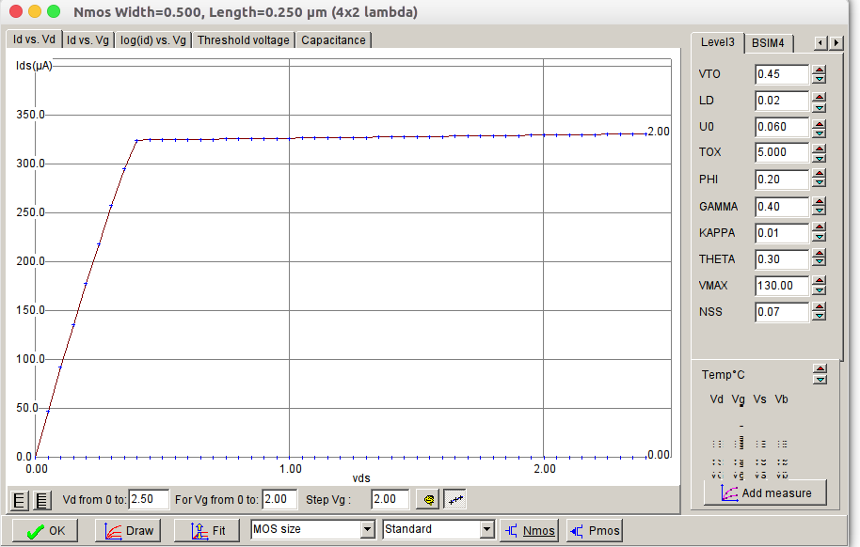Fig 2: Microwind generated nMOS characteristics curve

Conclusion: The characteristics curve of nMOS from manually calculated values of I_{DS} doesn’t vary significantly from automatically generated characteristics curve using Micro-wind. Micro-wind being a simulation software can include several influencing factor while plotting the characteristics curve.

